 | Semester 1 Examination 2010  Question/Answer Booklet

MATHEMATICS 3C/D

Section One

(Calculator Free)
Your name

Time allowed for this section
Reading time before commencing work: 5 minutes
Working time for paper: 45 minutes

Material required/recommended for this section

To be provided by the supervisor
Question/answer booklet for Section One.
Formula sheet.

To be provided by the candidate
Standard items: pens, pencils, pencil sharpener, highlighter, eraser, ruler.
Important note to candidates
No other items may be taken into the examination room. It is your responsibility to ensure that you do not have any unauthorised notes or other items of a non-personal nature in the examination room. If you have any unauthorised material with you, hand it to the supervisor before reading any further.

Structure of this examination

 | Number of questions | Working time (minutes) | Marks available
This Section (Section 1)  Calculator Free | 7 | 45 | 36
Section Two  Calculator Assumed | 10 | 90 | 72
Total marks |  |  | 108

Instructions to candidates

- The rules for the conduct of WACE external examinations are detailed in the booklet WACE Examinations Handbook. Sitting this examination implies that you agree to abide by these rules.

- Answer the questions in the spaces provided.

- Spare answer pages are provided at the end of this booklet. If you need to use them, indicate in the original answer space where the answer is continued i.e. give the page number.

- Show all working clearly. Any question, or part question, worth more than 2 marks requires valid working or justification to receive full marks. If you repeat an answer to any question, ensure that you cancel the answer you do not wish to have marked.
Section One (calculator-free) 36 Marks
This section has seven (7) questions. Answer all questions. Write your answers in the space provided.
Spare pages are included at the end of this booklet. They can be used for planning your responses and/or as additional space if required to continue an answer.
  - Planning: If you use the spare pages for planning, indicate this clearly at the top of the page.
  - Continuing an answer: If you need to use the space to continue an answer, indicate in the original answer space where the answer is continued, i.e. give the page number. Fill in the number of the question(s) that you are continuing to answer at the top of the page.

Suggested working time for this section is 45 minutes.

Question 1 (4 marks)
A function g(x) has a y intercept of 3 at point A. Find the image of point A under the following transformation:
(a) 2g(x) − 1 (1 mark)

(b) −g(3x + 6) + 4 (3 marks)

Question 2 (7 marks)
(a) Express with a common denominator and simplify
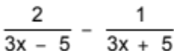 (3 marks)

(b) Simplify: 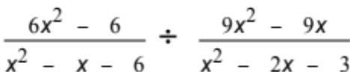 (4 marks)
Question 3 (5 marks)
For each of the following find the derivative with respect to x:
(a) 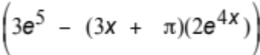 (2 marks)

(b) 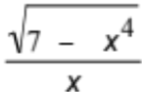 (Do not simplify your answer.) (3 marks)

Question 4 (3 marks)
(a) 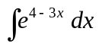 (1 mark)

(b) 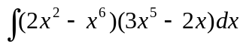 (2 marks)

Question 5 (7 marks)
Consider the following shaded region.
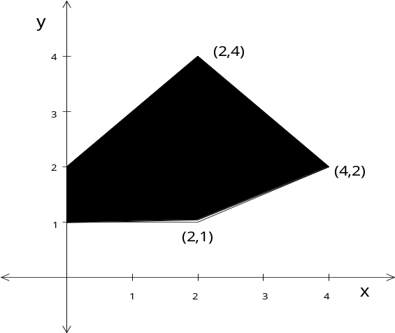
(a) Two inequalities that define the boundary of the region are given below. Find the remaining inequalities. (2 marks)
y ≤ x + 2 x + y ≤ 6

(b) Find the maximum value of the function G(x,y) = 2x – 3y in this region. (2 marks)

(c) Consider an objective function H = bx + 2y in the above region.
Find the values of b where the point (2,1) will always give the minimum value of H.
(3 marks)

Question 6 (4 marks)

Using the graph of 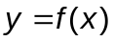 below, sketch a possible graph of 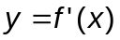 over the domain 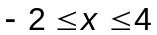.
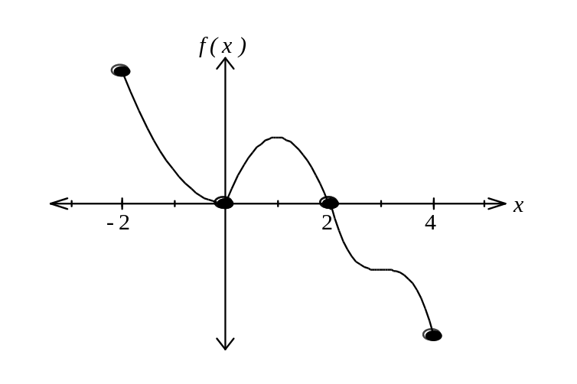

Question 7 (6 marks)
A computer software company, Alucinor, was feeling the effects of the recession and decided to advertise three separate training courses in word processing. Each course allows customers to evaluate some of the three different word processing programs Alucinor sells. In one course, X, they offer two hours on program B and one hour on program C, whilst course Y offers two hours on program A, thirty minutes on program B and one and a half hours on program C. Course Z consists of one hour on program A, one hour on program B and one and a half hours on program C.
Over one particular week, program A was used for 40 hours, program B for 62 hours and program C for 56 hours.
(a) For the above information, construct a system of linear equations. (2 marks)

(b) Solve the system of equations. (3 marks)

(c) If the fee per person for courses X, Y and Z are $50, $80 and $60 respectively, find the total income Alucinor receives in that week.
(1 mark)

